**Golden Bites POS System Phase1 Features**

|  |  |  |
| --- | --- | --- |
| **Date** | **Created By** | **To be Review By** |
| 10/26/2020 | Dhaval Patel, Devdutt Jadeja, Tirth Shah | Saad, Emmanuel |

**General Notes**

1. Entire system is hosted on the local machine, which means database for storing the data is installed on the local machine
2. system is not hosted on the web. System is running on the local machine.
3. Everything is working locally, in case you want to setup the system on another machine, we need to setup database and do technical configuration for the same.
4. The entire scope of the project only belongs to the Golden Bites restaurant

**Feature 1: Login Page**

Restaurant owner and working member of restaurant can login the system so they can place order for the customers of golden bites.

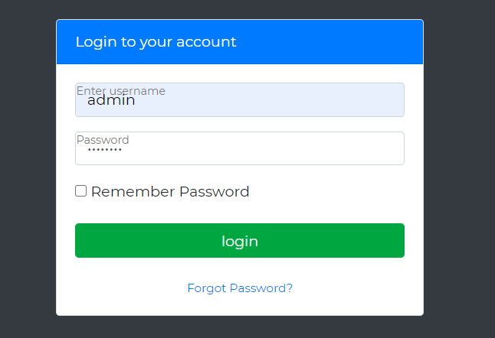

After login the main menu, have the following options:

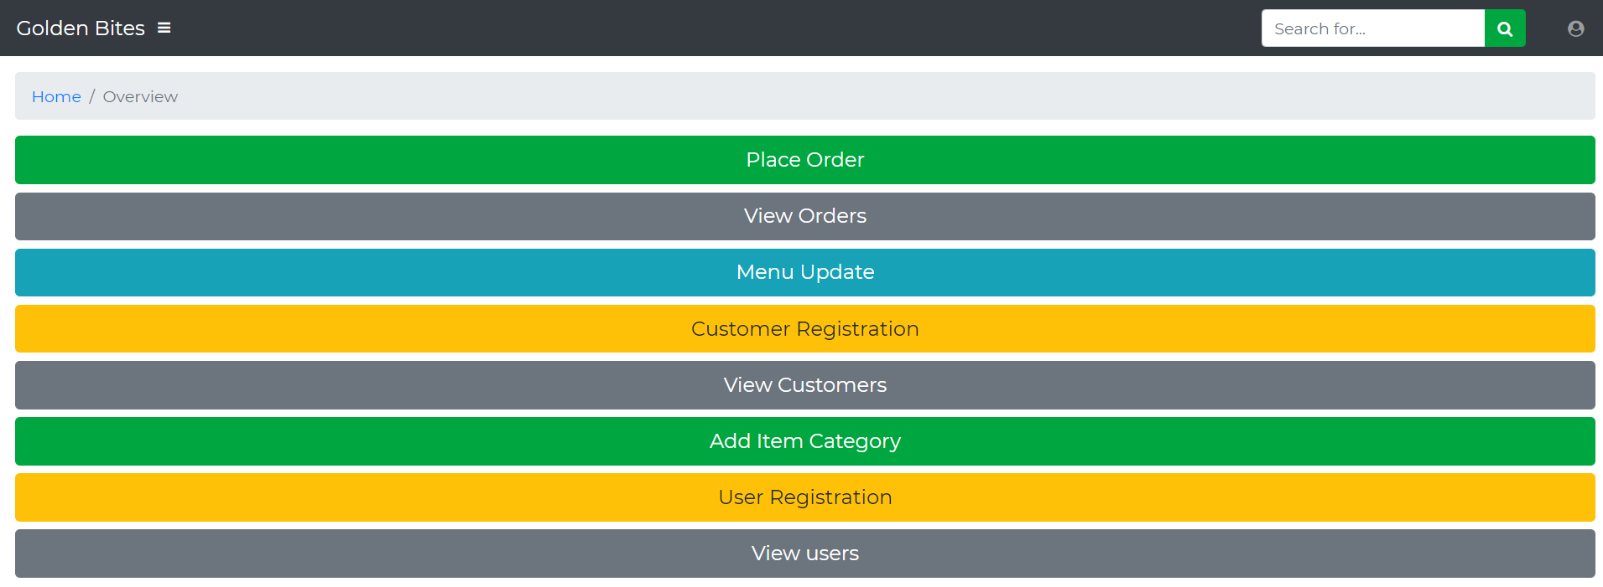

**Feature 2: Maintaining User Profile**

Each restaurant member or customer has it’s own login and password, this details are needed to login the system.

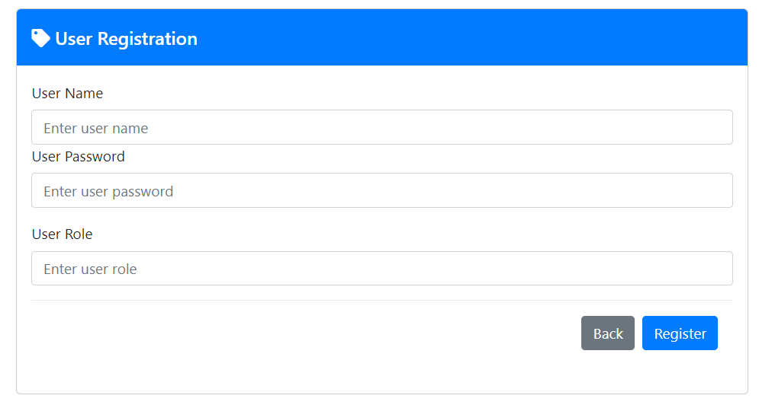

Using below feature you can see all the users that can login to system. Here you can update or delete the users as well

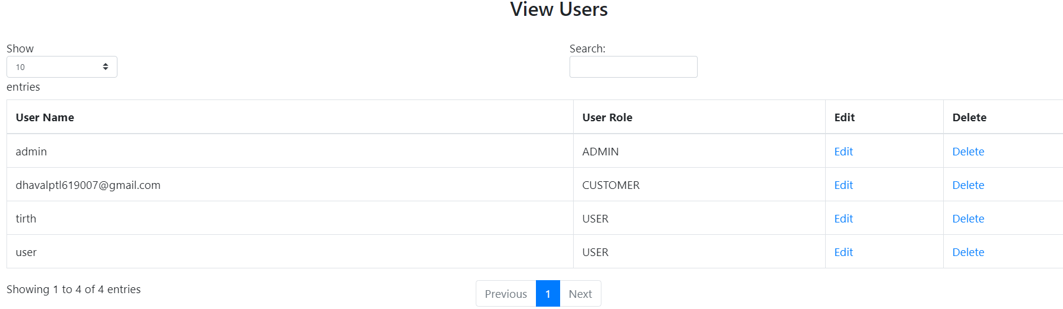

**Feature 3: Configure Menu of the Restaurant**

Restaurant owner can configure the menu, they can also maintain the price and tax related details of the item.

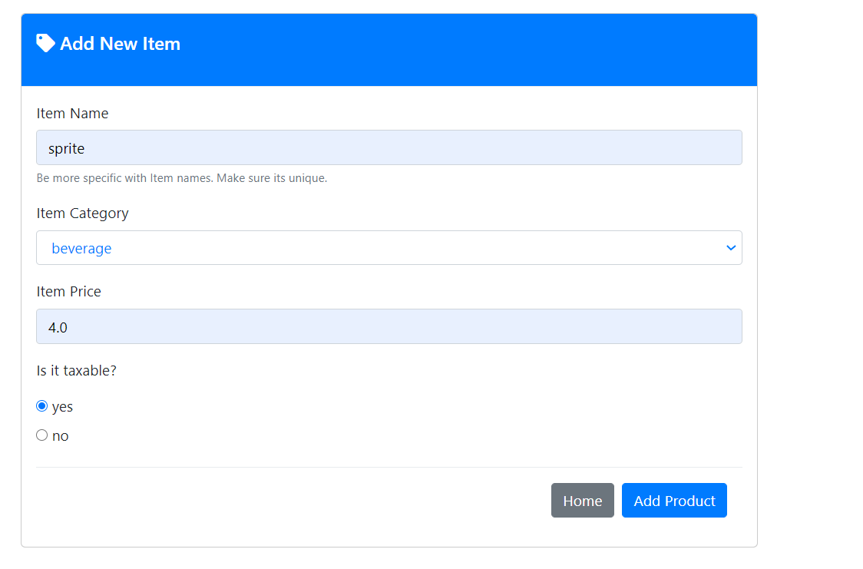

Also, can add item category

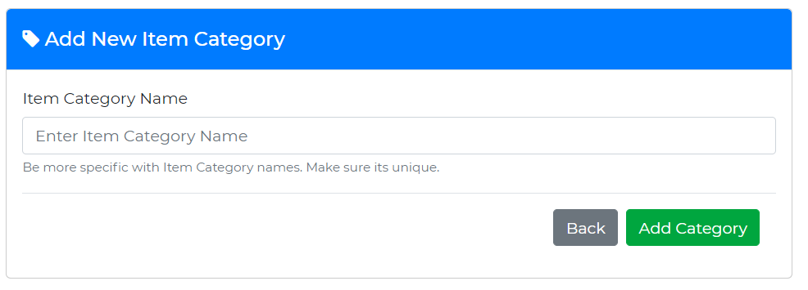

Can view item details as well, updating and deletion is possible

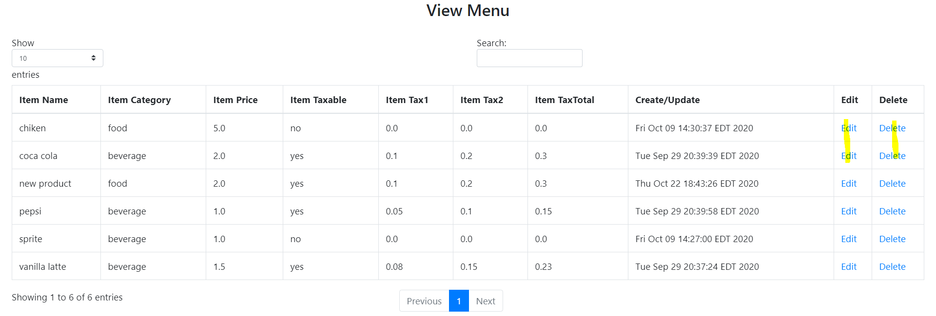

**Feature 4: Register the customer**

As the owner of the restaurant, you have ownership to register the customer

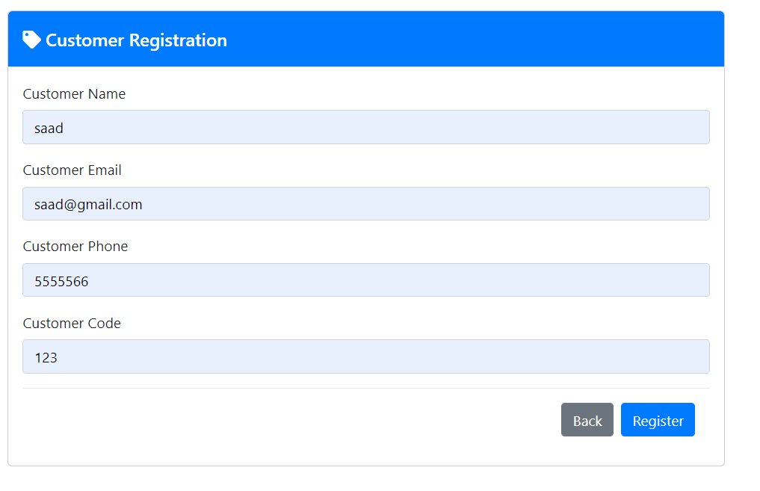

Here in the customer code, barcode number can be entered

It is possible to view all the customers of the restaurant, also restaurant owner can edit or delete the customer details

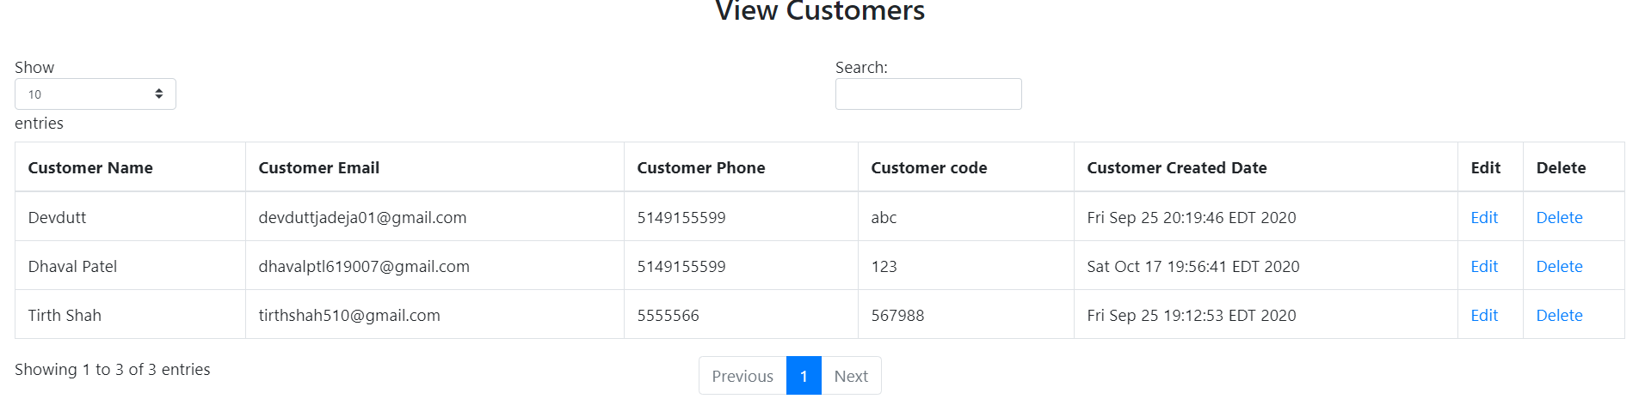

**Feature 4: Place Order**

Restaurant owner can place order, during placing the order, owner can modify the order, can select the customer for which, want to place the order

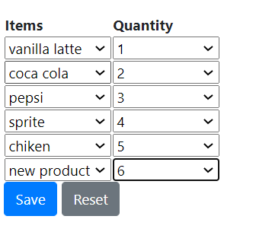

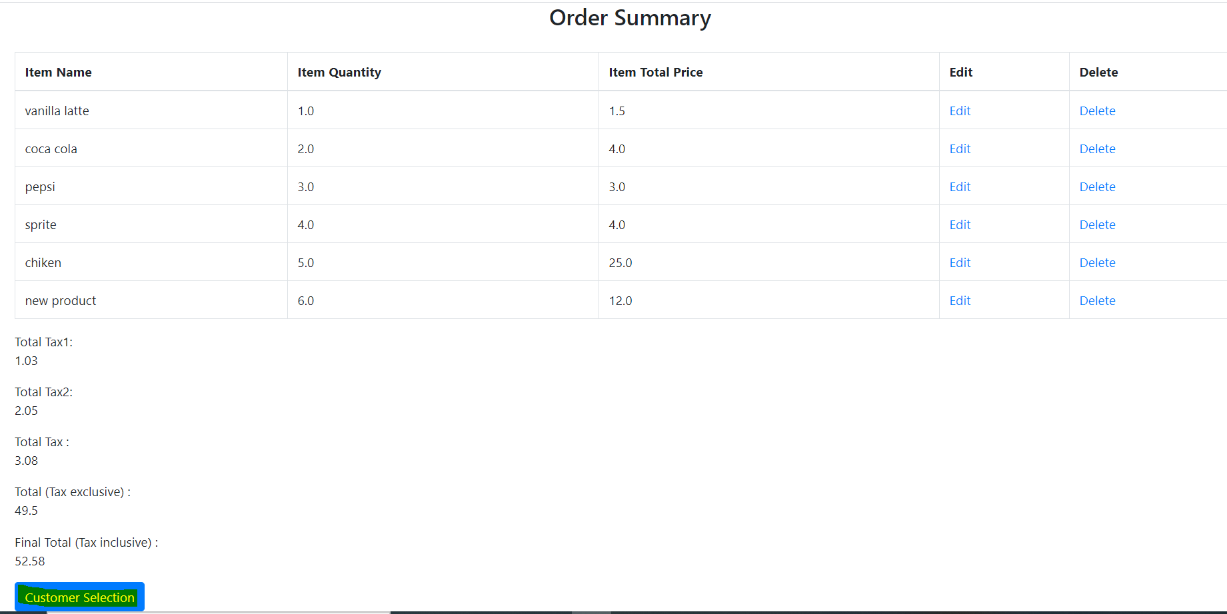

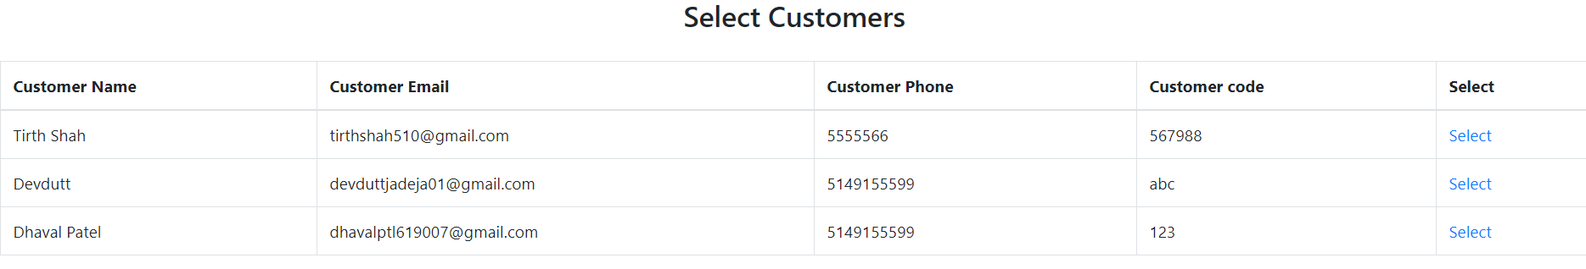

Order placed successfully

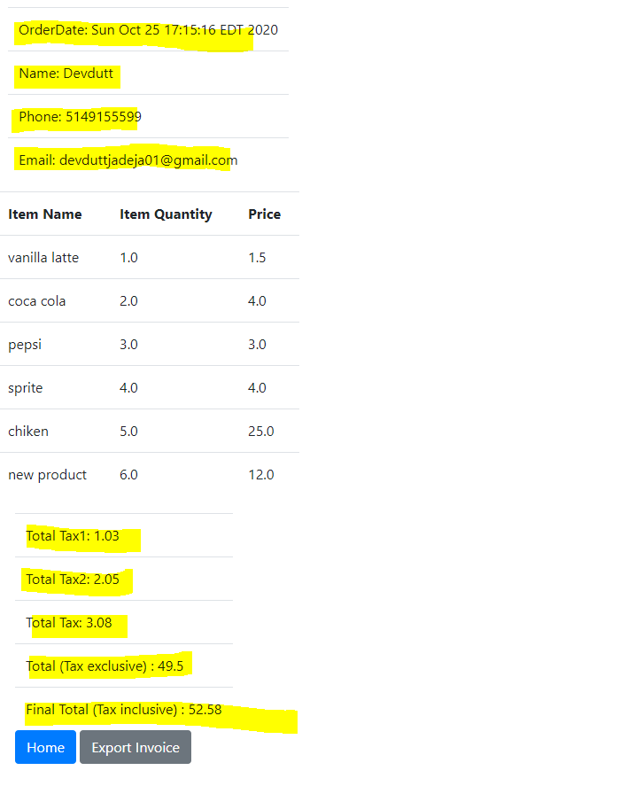

Owner can download the invoice receipt: the receipt looks like below.

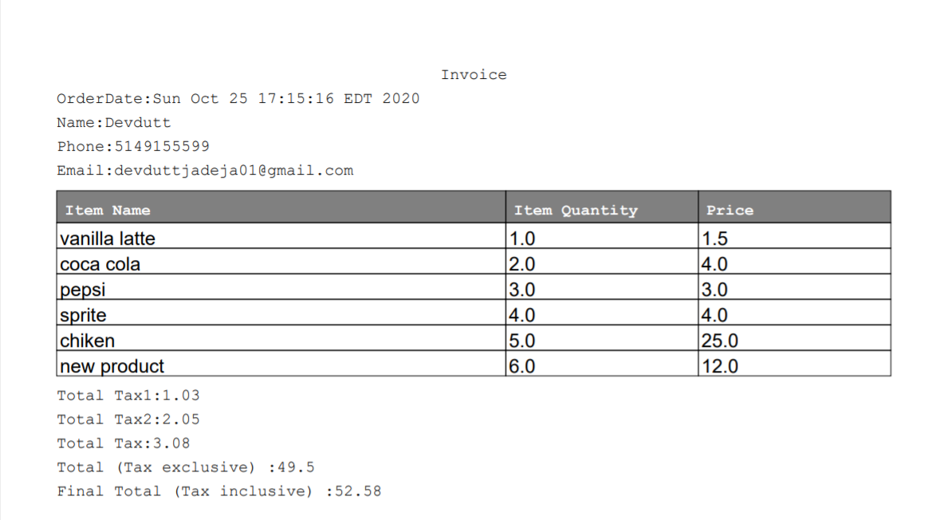

**Feature 5: View Orders**

Using date filter, owner can view the old orders and view the order receipts

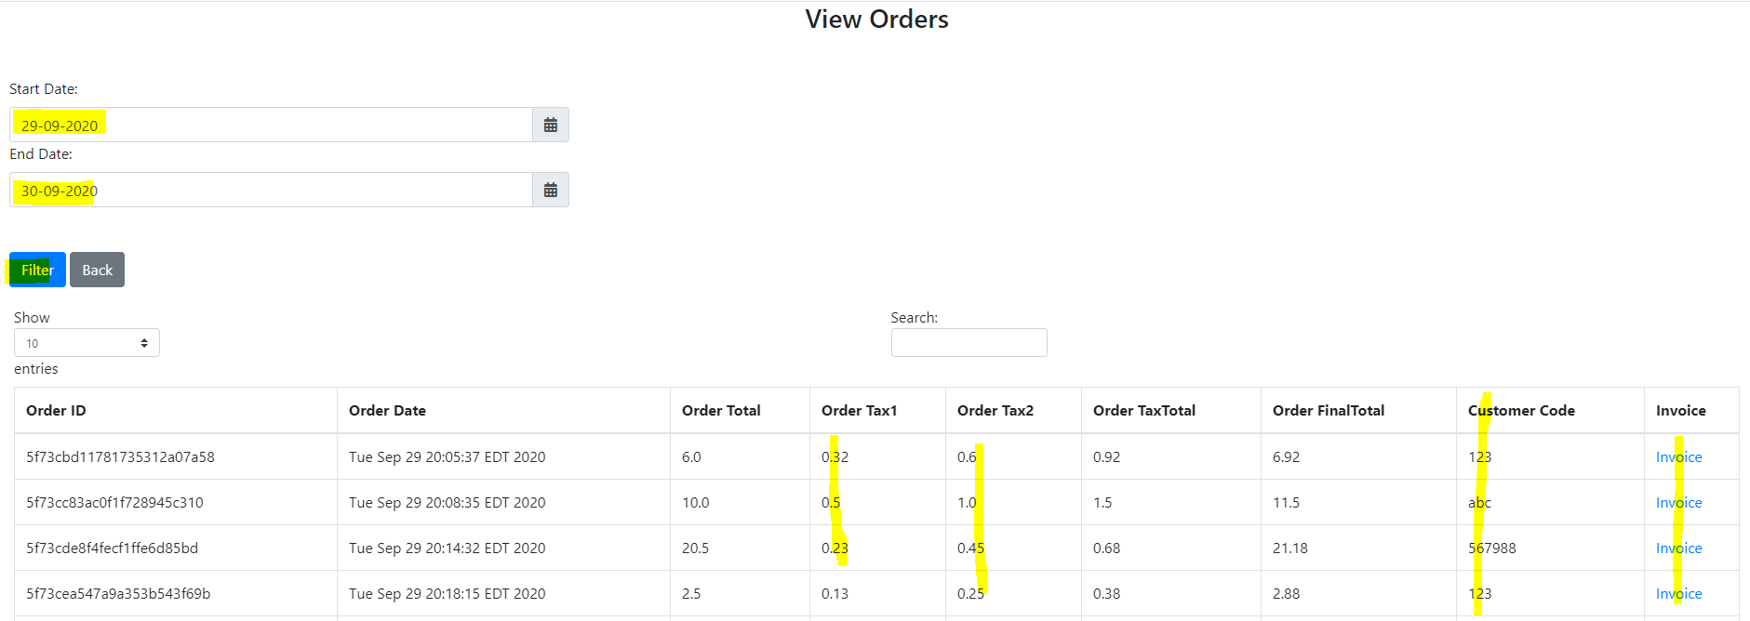

**Feature 6: Customer Login GUI**

Every customer can login with email address to the portal.

new customer, first time can register themselves via portal

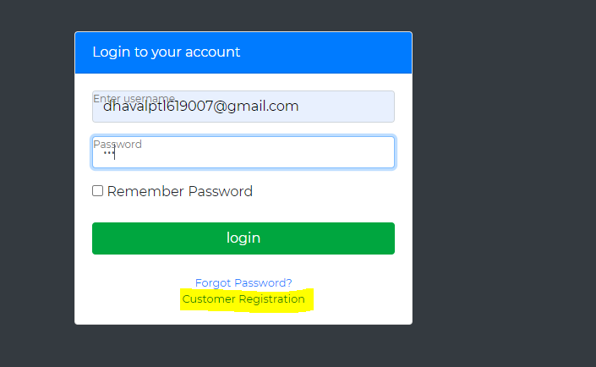

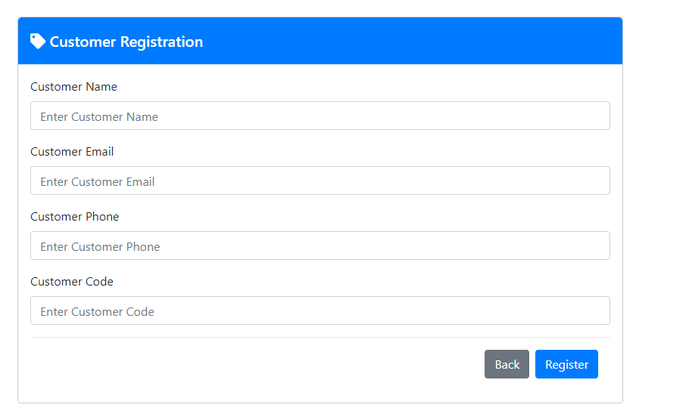

Using this portal customer can view only his/her orders and can download the receipts.

Note that customer application is different from the POS system portal